Representing Data
Data can be categorised as numeric, alphanumeric characters or strings of characters (strings). Whatever the data, it will be represented by the computer in binary. We have already seen how binary can be used to represent whole numbers but it can also be used to represent integers, numbers with fractional parts (real numbers), instructions for the computer to follow (programs/code), images, graphics, sound and the text.

Representing Text
To make the passing of data from one computer to another easy, a standard form of representing characters was adopted by computer manufacturers. The American Standard Code for Information Interchange (ASCII).
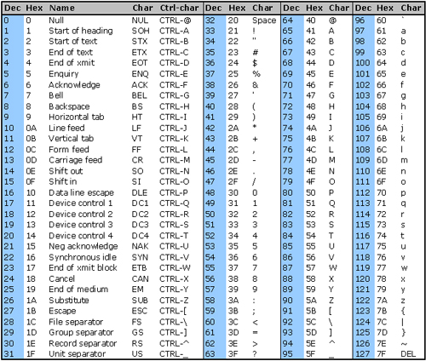
Work out what these codes say. The numbers are the decimal code for a character.
73 | 32 | 108 | 111 | 118 | 101 | 32 | 109 | 121 | 32

99 | 111 | 109 | 112 | 117 | 116 | 101 | 114 | 33

Now convert this into binary. Each character must be represented by an 8-bit binary number. An 8-bit binary number is called a BYTE.

Tasks:
- Find out what Extended ASCII is
- What is Unicode
- In both of the above, explain why they are needed

